- Addendum #1 is the sign-in sheet from the 14OCT site meeting.

- To give contractors more time to determine the details of their proposals, the Port has delayed the submittal deadline to 31OCT2025 at 3PM. The Port is also still analyzing the proper answer to the questions of ownership during destruction, and at what point liability for the vessels passes to the contractor. Anticipate an addendum addressing these issues early during the week of 20OCT2025.

- Performance bond and bid bonds are required for this project.

- The Port has fielded several inquiries about who is responsible for hazardous materials testing such as lead, asbestos, etc. and whether any testing has taken place. During the 14OCT site meeting, the Port indicated to all in attendance that no testing has taken place and that such testing, remediation, and disposal is part of this project and is the responsibility of the contractor. See item 1.B.5. in the scope of work contained in the RFP.

- MANU OKU sank just following the release of the RFP; raising and disposal of that vessel is part of this project. There is no oil or diesel or pollution risks aboard. the Port has already reported this to the Coast Guard and Oregon Department of State Lands.

- The Port will allow for billing by the contractor for each individual vessel as they are disposed of. The Port will make payment for the towing, dismantling, hauling, and disposal of each vessel when the Port is presented with disposal receipts and/or when the vessel is removed from the Port, along with proof of final disposition is presented for each vessel. Invoices shall be due within 30 days of receipt. Approval of follow-on work within the project may be subject to funding availability and reimbursement of the Port by Oregon Department of State Lands.

- Item 1.B.3. in the scope of work is amended to delete the 30NOV2025 date. In addition to the language in that section, ADD: BUSTER is considered to be the most critical vessel to be removed and shall be first in the order of disposal. Upon execution of contract, contractor is liable for the custodial care, safety, and disposal of BUSTER, ECLIPSE, and SEAWOLF. The Port will transfer custodial care of each additional vessel at such time that the contractor indicates to the Port in writing that they have begun work to move or dismantle each boat or at which point the Port observes that the contractor has begun work or moved any vessel in this agreement.

Photo of Buster: 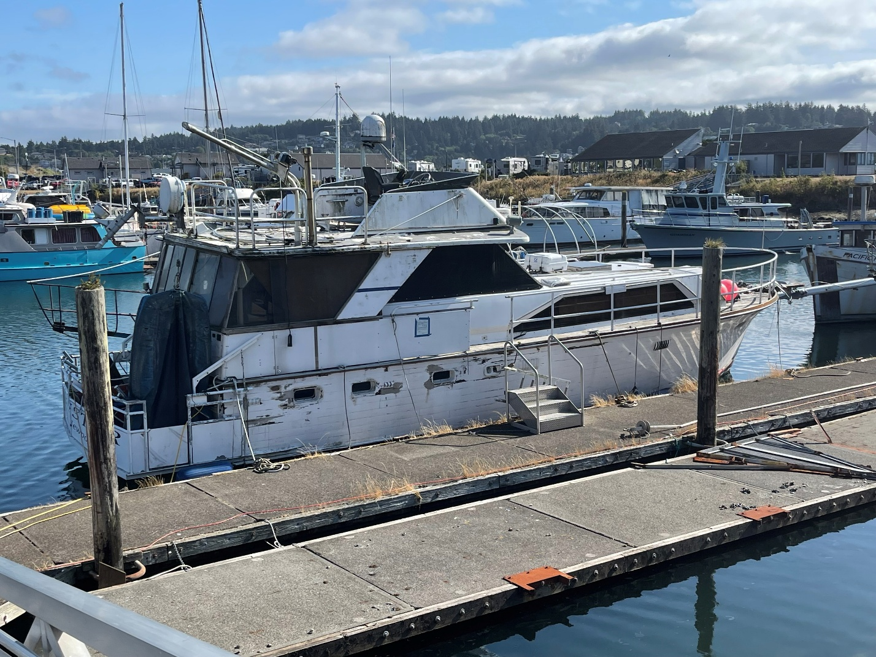

- Gross tonnage of all the vessels is not available.

- Any contractors or subcontractors hauling waste as part of this project shall adhere to all local, state, and federal laws and regulations, including but not limited to local municipal codes related to waste disposal and franchised haulers.

- Any use of the South Beach boat ramp is subject to traffic restrictions that may be imposed by the Port of Newport. Contractors requesting to use the boat ramp shall submit loading information as part of their proposal. The Port of Newport will consult with the Oregon State Marine Board to consider whether the requests for loading of the boat ramp will be approved, or whether the contractor will be required to alter their plans. The Port of Newport shall be the final determining authority regarding any use of the boat ramp, and may approve or reject any proposals to use the boat ramp based on any characteristic the Port deems relevant. General information about the loading of boat ramps from the Oregon State Marine Board is attached to this addendum.

- The Port of Newport may choose not to accept proposals involving demolition on Port property if there is no approved solid waste disposal permit from Oregon DEQ and/or any aspects of the plan are not acceptable to the Port of Newport.

- Contractors shall propose in writing how proceeds from material that is recycled, reused, or sold benefit the project. If there is no benefit from these types of uses, proposers shall indicate that as part of their proposal. This is REQUIRED for all proposals submitted for this opportunity.

- Further questions regarding any bid documents or terms of this solicitation shall be submitted in writing to abretz@portofnewport.com ; the deadline for questions is 3PM on 24OCT2025.

