PORT OF NEWPORT
NOAA PIER FIRE DAMAGE

PREBID QUESTIONS

- Not details are provided for existing rebar at the bullrail. Are we to assume that this is cut the same as the rebar from the deck panels to the cap beams?

- Is there a closure pour required at the bullrail after installation of the precast? If so, please provide details.
Here is an excerpt from the original design:

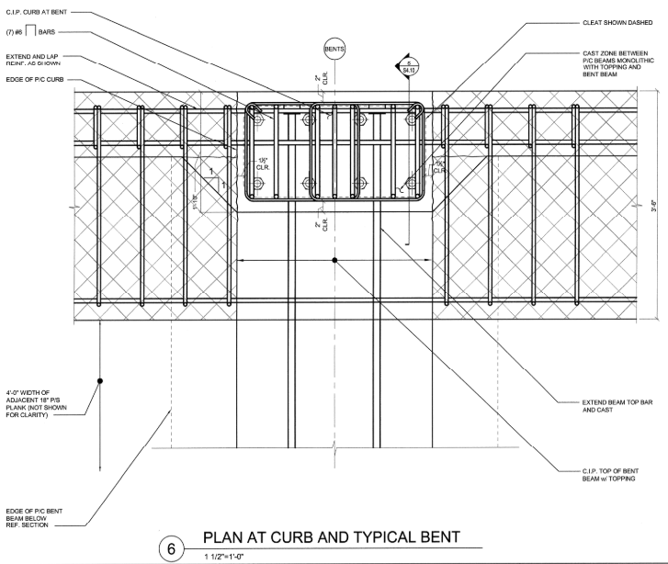

- Detail 1 on Sheet S4.1 requires conduit to be embedded in the precast bullrail beam and stubbed out for connection to existing. This will not work with the current demolition limits outlined on Sheet S1.1. Connection of the conduits would require extensive demolition around the cleats at bents 3 and 4. The detail below from the original bid in 2010 shows that no utilities extend west of Bent 4. Can the Port confirm if these conduits are actually needed? If they are, please provide further details.

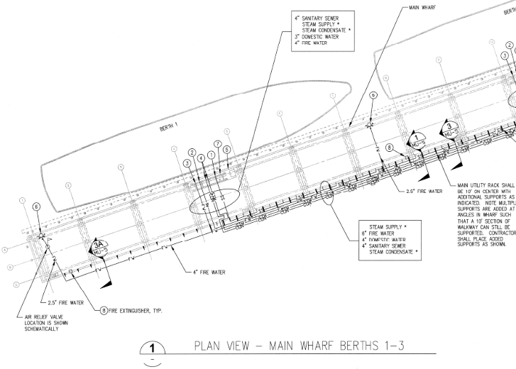

- Sheet S2.1 indicates replacing the exterior precast beam (which includes the bullrail) plus 3 additional interior slabs. Page 10 of the NOAA Fire Damage Narrative indicates the exterior beam plus two voided slabs. Which one is correct?

