PORT OF NEWPORT
NOAA PIER FIRE DAMAGE

PREBID QUESTIONS

- Not details are provided for existing rebar at the bullrail. Are we to assume that this is cut the same as the rebar from the deck panels to the cap beams?
KPFF – Yes. The intent at the bull rail beam is the same as at the precast slabs.

- Is there a closure pour required at the bullrail after installation of the precast? If so, please provide details. KPFF – No closure pour is required. The detail below shows the bull rail/cleat connection at the top of the bent beam and is intended to remain. The bull rail beams are shown hatched to either side.
Here is an excerpt from the original design:

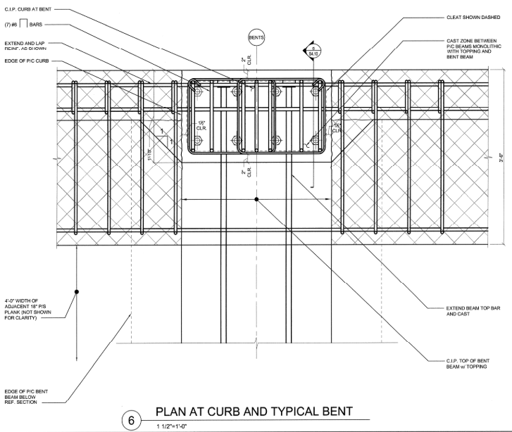

- Detail 1 on Sheet S4.1 requires conduit to be embedded in the precast bullrail beam and stubbed out for connection to existing. This will not work with the current demolition limits outlined on Sheet S1.1. Connection of the conduits would require extensive demolition around the cleats at bents 3 and 4. The detail below from the original bid in 2010 shows that no utilities extend west of Bent 4. Can the Port confirm if these conduits are actually needed? If they are, please provide further details. KPFF – Based on the existing utility record drawings, we anticipate all the utilities within the bull rail beam to terminate at the utility bunker between grids 4 and 5. However, in the structural record drawings the detailed bull rail beam section between grids 3 and 4 is shown with conduits but is noted as a sim condition, without defining the sim condition. These drawings also indicate the bull rail beam between grids 2 and 3 does not contain conduits. Based on this information, we suspect the sim condition was intended to indicate no conduits within the bull rail beam between grids 3 and 4, and we anticipate this is the case.

There is a small potential that conduits exist within the bull rail beam being replaced. If conduits are discovered during demolition the conduits will need to be provided. Notify the Port for requirements to re-establish the conduits if found during demolition.

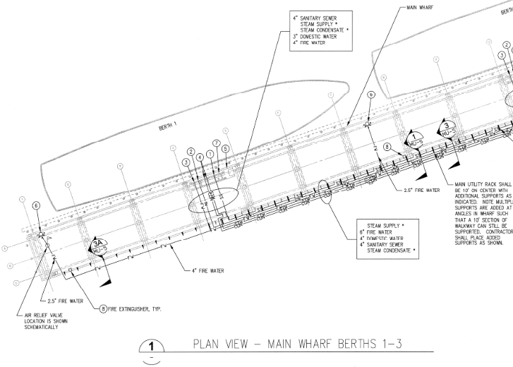

- Sheet S2.1 indicates replacing the exterior precast beam (which includes the bullrail) plus 3 additional interior slabs. Page 10 of the NOAA Fire Damage Narrative indicates the exterior beam plus two voided slabs. Which one is correct?
KPFF – Page 10 of the NOAA Fire Damage Narrative indicates the exterior bull rail beam and the first two voided slabs have significant shallow concrete spalling and the third voided slab has minor shallow concrete spalling. Figure 16 of the narrative indicates the concrete edge beam (bull rail beam) and three voided slabs are fire damaged.

As indicated on S1.1 and S2.1 of the repair drawings, the bull rail beam and three voided slabs are to be replaced due to fire damage.

